APPLICATION DATA SHEET: TACHOMETER AND SPEED SWITCH
Page 1 of 1
Quote Reference: |  |  |  |  | Tag Name:
Customer: |  |  |  |  |  | End-User:
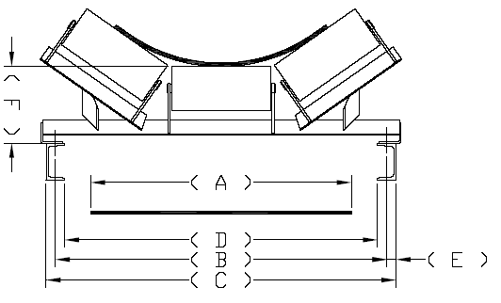 |  |  |  |  |  |  |  |  |  |  |  | DIM |  | MEASURED DIM
 |  |  |  |  |  |  |  |  |  |  |  | A = |  |  |  | mm
 |  |  |  |  |  |  |  |  |  |  |  | B = |  |  |  | mm
 |  |  |  |  |  |  |  |  |  |  |  | C = |  |  |  | mm
 |  |  |  |  |  |  |  |  |  |  |  | D = |  |  |  | mm
 |  |  |  |  |  |  |  |  |  |  |  | E = |  |  |  | mm
 |  |  |  |  |  |  |  |  |  |  |  | F = |  |  |  | mm
APPLICATION DETAILS
Belt Speed (m/min)) |  |  |  | (Maximum) |  |  |  |  |  |  | (Normal) |  |  |  | (Minimum)
Environmental temperature (°C) |  |  |  | (Maximum) |  |  |  |  |  |  | (Normal) |  |  |  | (Minimum)
Hazardous location |  |  | YES NO
Severe vibration on Conveyor |  |  | YES NO
GENERAL OPTIONS
Stringer mounting assembly required? |  |  | Yes No |  |  |  | (Mark Choice)
Stringer mounting assembly coating? |  |  | PA Proprietary (Blue) Galvanized Other (as per attached)
Junction Box requred? |  |  | Yes No |  |  |  | (Mark Choice)
Interconnecting Cable required |  |  | Yes No |  |  |  | meters

SPECIAL REQUIREMENTS (NOT LISTED ABOVE)
CONFIRMATION OF TECHNICAL DETAILS AS SET OUT ABOVE (requirement of ISO 9001)
Print Name: |  |  | Designation:
Signature: |  |  | Date:

